CSA0501-DATABASE MANAGEMENT SYSTEMS
LAB EXPERIMENTS DATE:12/07/2026

EXPERIMENT 3 -- DML Commands (INSERT, SELECT)
AIM:
To perform Data Manipulation Language (DML) commands such as INSERT and SELECT in the Intern_emp_info tables.
PROCEDURE:
- Open the SQL environment (Oracle SQL, MySQL, or SQL Developer).
- Create the required tables (DEPARTMENT, FACULTY, and INTERN) with the necessary columns and constraints.
- Use the INSERT command to add records into each table.
- Execute the SQL statements and verify that the records are inserted successfully.
- Use the SELECT command to retrieve all the records from each table.
- Verify the displayed data to ensure it matches the inserted values.
- Save the SQL script and record the output for verification.

PROGRAM:
1. INSERT INTO DEPARTMENT TABLE:
INSERT INTO DEPARTMENT
VALUES
(101,'Information Technology','Block A'),
(102,'Computer Science','Block B'),
(103,'Artificial Intelligence','Block C');

OUTPUT:
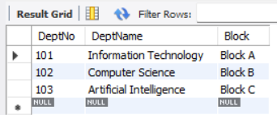

2. INSERT INTO Faculty:
INSERT INTO FACULTY
VALUES
(201,'Anitha','F',101),
(202,'Rahul','M',102),
(203,'Priya','F',103);
OUTPUT:
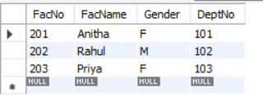

3. INSERT INTO INTERN:
INSERT INTO INTERN
VALUES
(301,'M.NithyashreeNarayani','Python Developer',201),
(302,'R.Idhaya','Web Developer',202),
(303,'Karthik','AI Intern',203);
OUTPUT:
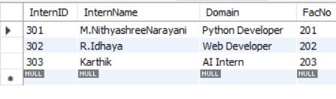

4.VIEW ALL TABLES:
SELECT * FROM Department;
SELECT * FROM Faculty;
SELECT * FROM Intern;
OUTPUT:




RESULT:
Thus the Data Manipulation Language (DML) commands such as INSERT and SELECT were successfully executed and verified in the Intern_emp_info System.

